DUXFORD FLY-AWAY DAY – 21/07/2013
Everyone turned up diligently at 08:30 in order to get an early start but, after weeks of scorching weather, the weather had other plans. The conditions were perfectly flyable in the West of the country but there was low cloud and mist to the East, particularly around Coventry and Cranfield. After a study of the TAFS and METARS, all adjourned to the Aviator Café for breakfast.
The parties in the flyout were (from left to right) :
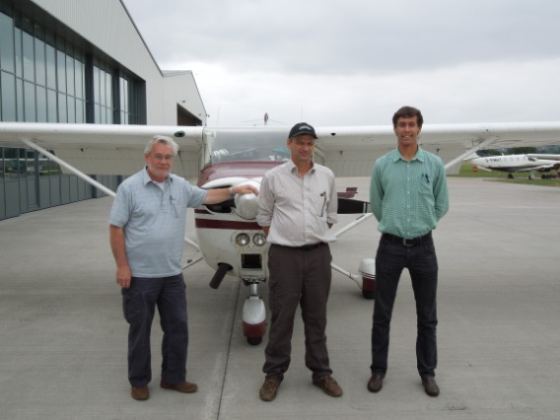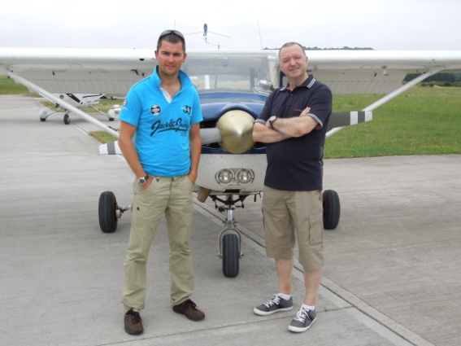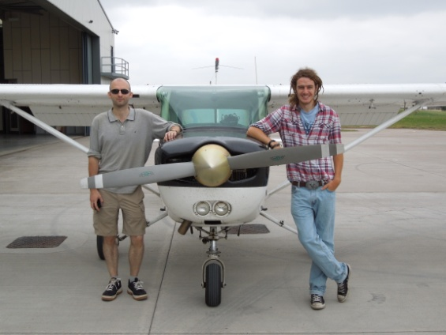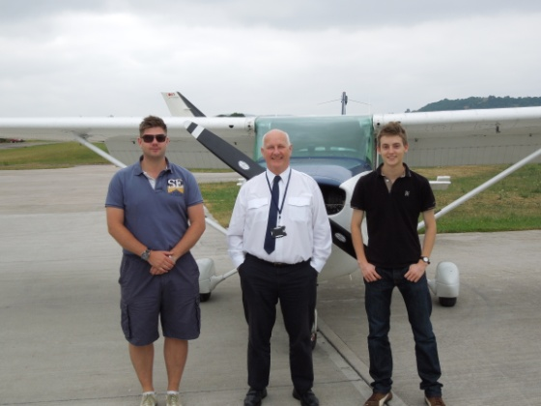
Alan Tague, Rowland Slatter and Adam Knights | Chris Evans and Bob Pearce | Paul Jones and Dion Robertson | Kev Bennett, Kim Hampshire and Mark Gwilt

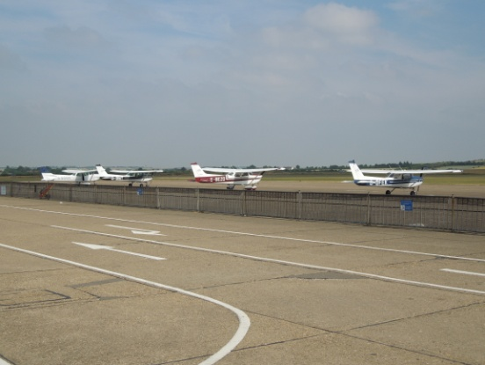
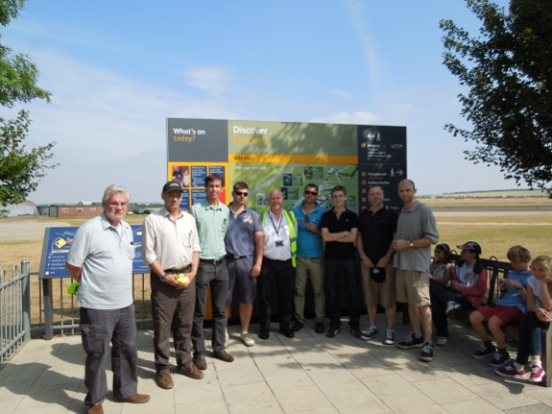
The weather showed signs of improvement but was tantalisingly slow to clear in the Midlands. After further deliberations, everyone adjourned to the Aviator Café for lunch. After lunch, eventually the TAFS indicated that the route to Duxford was suitable and suddenly at 14:00 the Staverton Flying School briefing room was empty, aircraft were started and all four aircraft took off for Duxford. Immediately on take-off there was a parachute drop to be avoided overhead the racecourse at Cheltenham. All four aircraft followed the same route to Duxford : Gloucester – Banbury – Daventry VOR – passing North of Cranfield to Bassingbourne – Duxford and was enjoyed by all crews. For Mark it was his first flight in the Cessna 172 and his first flight using the VOR.
Shortly after arrival at Duxford, all gathered for a group photo (a rougues gallery!), all except Dion who was already off exploring the site. The SFS fleet made a nice group on the apron at Duxford. Duxford is an amazingly well laid out museum including flying exhibits and it was not possible give it the attention it deserved in the time remaining. However for all of us it was the journey that was more the attraction than the venue. The return journey was enjoyed by all with better weather but the low sun in hazy conditions making navigation interesting.
After the paperwork was concluded, it was off to the Aviator Café for refreshments.

